**EXPERIMENT NO : 8**

**DATE : 25-02-2025**

**AIM :** Write a Java program to store employee details including employee number, name, and salary, and search for an employee by employee number.

**SOURCE CODE**

import java.util.ArrayList;

import java.util.Scanner;

class Employee {

int empNumber;

String empName;

double empSalary;

Employee(int empNumber, String empName, double empSalary) {

this.empNumber = empNumber;

this.empName = empName;

this.empSalary = empSalary;

}

void displayEmployeeDetails() {

System.out.println("Employee Number: " + empNumber);

System.out.println("Employee Name: " + empName);

System.out.println("Employee Salary: " + empSalary);

}

}

public class EmployeeDetails {

public static void main(String[] args) {

Scanner scanner = new Scanner(System.in);

ArrayList<Employee> employeeList = new ArrayList<>();

System.out.print("Enter the number of employees: ");

int numberOfEmployees = scanner.nextInt();

scanner.nextLine();

for (int i = 0; i < numberOfEmployees; i++) {

System.out.println("\nEnter details for employee " + (i + 1));

System.out.print("Enter employee number: ");

int empNumber = scanner.nextInt();

scanner.nextLine();

System.out.print("Enter employee name: ");

String empName = scanner.nextLine();

System.out.print("Enter employee salary: ");

double empSalary = scanner.nextDouble();

scanner.nextLine();

employeeList.add(new Employee(empNumber, empName, empSalary));

}

System.out.print("\nEnter employee number to search: ");

int empNumberToSearch = scanner.nextInt();

boolean found = false;

for (Employee emp : employeeList) {

if (emp.empNumber == empNumberToSearch) {

emp.displayEmployeeDetails();

found = true;

break;

}

}

if (!found) {

System.out.println("Employee not found with employee number: " + empNumberToSearch);

}

scanner.close();

}

}

**OUTPUT**

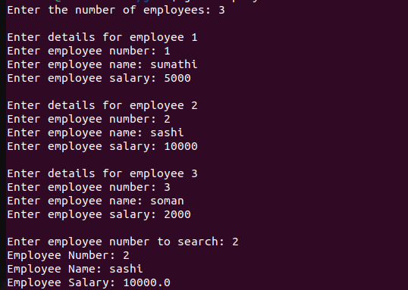

**EXPERIMENT NO : 9**

**DATE : 25-02-2025**

**AIM :** Write a Java program to store ‘n‘ strings in an array. Search for a given string. If found, print its index; otherwise, display ”String not found.”

**SOURCE CODE**

import java.util.Scanner;

public class StringSearch {

public static void main(String[] args) {

Scanner scanner = new Scanner(System.in);

System.out.print("Enter the number of strings you want to store: ");

int n = scanner.nextInt();

scanner.nextLine();

String[] strings = new String[n];

System.out.println("Enter the strings:");

for (int i = 0; i < n; i++) {

System.out.print("String " + (i + 1) + ": ");

strings[i] = scanner.nextLine();

}

System.out.print("\nEnter the string to search: ");

String searchString = scanner.nextLine();

boolean found = false;

for (int i = 0; i < n; i++) {

if (strings[i].equals(searchString)) {

System.out.println("String found at index: " + i);

found = true;

break;

}

}

if (!found) {

System.out.println("String not found.");

}

scanner.close();

}

}

**OUTPUT**

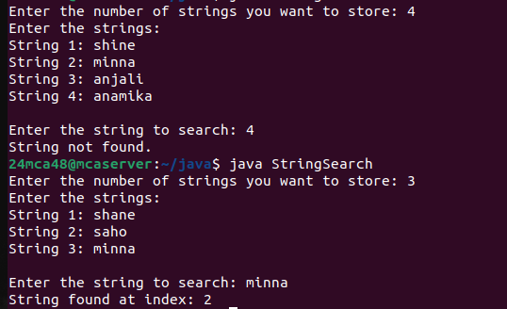

**EXPERIMENT NO : 10**

**DATE : 25-02-2025**

**AIM :** Write a Java program to perform various string manipulations, including finding the

length, converting to uppercase and lowercase, extracting characters and substrings, and

reversing the string.

**SOURCE CODE**

import java.util.Scanner;

public class StringManipulations {

public static void main(String[] args) {

Scanner scanner = new Scanner(System.in);

System.out.print("Enter a string: ");

String inputString = scanner.nextLine();

int length = inputString.length();

System.out.println("Length of the string: " + length);

String upperCaseString = inputString.toUpperCase();

System.out.println("String in uppercase: " + upperCaseString);

String lowerCaseString = inputString.toLowerCase();

System.out.println("String in lowercase: " + lowerCaseString);

char firstChar = inputString.charAt(0);

System.out.println("First character: " + firstChar);

String substring = inputString.substring(2, 5);

System.out.println("Substring from index 2 to 5: " + substring);

String reversedString = new StringBuilder(inputString).reverse().toString();

System.out.println("Reversed string: " + reversedString);

scanner.close();

}

**OUTPUT**

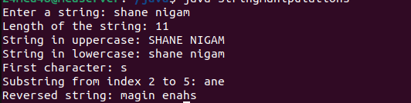

**EXPERIMENT NO : 11**

**DATE : 25-02-2025**

**AIM :** Write a Java program to implement hierarchical inheritance for a book management

system. Define a base class ‘Publisher‘, a derived class ‘Book‘, and two subclasses ‘Liter-

ature‘ and ‘Fiction‘. Include methods to read and display book details and demonstrate

the functionality using user input.

**SOURCE CODE**

import java.util.Scanner;

class Publisher {

String publisherName;

String publisherAddress;

void readPublisherDetails(Scanner scanner) {

System.out.print("Enter publisher name: ");

publisherName = scanner.nextLine();

System.out.print("Enter publisher address: ");

publisherAddress = scanner.nextLine();

}

void displayPublisherDetails() {

System.out.println("Publisher Name: " + publisherName);

System.out.println("Publisher Address: " + publisherAddress);

}

}

class Book extends Publisher {

String bookTitle;

String author;

double price;

void readBookDetails(Scanner scanner) {

System.out.print("Enter book title: ");

bookTitle = scanner.nextLine();

System.out.print("Enter author name: ");

author = scanner.nextLine();

System.out.print("Enter book price: ");

price = scanner.nextDouble();

scanner.nextLine();

}

void displayBookDetails() {

System.out.println("Book Title: " + bookTitle);

System.out.println("Author: " + author);

System.out.println("Price: " + price);

}

}

class Literature extends Book {

String genre;

void readLiteratureDetails(Scanner scanner) {

readBookDetails(scanner);

System.out.print("Enter genre of literature: ");

genre = scanner.nextLine();

}

void displayLiteratureDetails() {

displayBookDetails();

System.out.println("Genre: " + genre);

displayPublisherDetails();

}

}

class Fiction extends Book {

String subGenre;

void readFictionDetails(Scanner scanner) {

readBookDetails(scanner);

System.out.print("Enter fiction subgenre: ");

subGenre = scanner.nextLine();

}

void displayFictionDetails() {

displayBookDetails();

System.out.println("Subgenre: " + subGenre);

displayPublisherDetails();

}

}

public class BookManagementSystem {

public static void main(String[] args) {

Scanner scanner = new Scanner(System.in);

Literature literatureBook = new Literature();

Fiction fictionBook = new Fiction();

System.out.println("\nEnter details for Literature book:");

literatureBook.readPublisherDetails(scanner);

literatureBook.readLiteratureDetails(scanner);

System.out.println("\nLiterature Book Details:");

literatureBook.displayLiteratureDetails();

System.out.println("\nEnter details for Fiction book:");

fictionBook.readPublisherDetails(scanner);

fictionBook.readFictionDetails(scanner);

System.out.println("\nFiction Book Details:");

fictionBook.displayFictionDetails();

scanner.close();

}

}

**OUTPUT**

